Names: ______Colin Quinn_______ and _______Bailey Scott_________ and _______________________________

**Week 2: Chemical Composition of Cells:  
Please note that this lab corresponds with the Connect resources   
Carbohydrates** “chemical composition of cells: digestion of starch, , test for starch, test for sugars) and endocrine system: effects of blood glucose level

**Proteins**: “chemical composition of cells: test for proteins”

**Lipids:** “chemical composition of cells: emulsification of lipids, test for fat”

**Relevant textbook passages:**Chapter 2 pp. 29-39, Chemical Composition of cells sections 3 through 7 (carbohydrates, lipids, proteins, and nucleic acids) from your textbook.

**Complete the worksheet using your textbook and Connect. For any questions that you need to Google (marked with an asterick)*, please do so but provide a link to a CREDIBLE SOURCE. Answers that are not from credible sources will**

**I. Review:**

1. Review from week 1 discussion: What is a positive control?*

A group that would receive something that has a known outcome.

2. From the pillbug experiment last lab did you have a positive control?

No, we did not know whether they would be attracted to the corn starch.

3. Review from week 1 discussion: What is a negative control?*

A group that is treated the same as other samples but are not expected to change due to any variable in the experiment.

4. From the pillbug experiment last lab did you have a negative control?

Yes, it was our control group.

5. From last week’s lab, what are the steps of the scientific method?

Observe, ask a question, form a hypothesis, design a test, run the experiment, analyze data.

**II. Carbohydrates**

1. (B) What are 3 examples of a carbohydrate that you might eat and what is the dietary source? Check out this link: https://www.nap.edu/read/9826/chapter/5  
Example: Glucose, found in honey and fruits.

Fructose, found in honey and tree/vine fruits, berries, and root vegetables. Pectins are usually found in fruit like apples. Lactose is found in dairy like milk and cheese.

2a. What form does your body store excess glucose as, according to your textbook?

Glycogen

2b.What do we call the building block of a carbohydrate (monomer)?

Monosaccharide

3. What is starch broken down to what inside your body, according to your textbook?

Constituent sugars like glucose

4. From Connect, What solution is used to test for starch? How does it work*?

Iodine, when starch is present it will turn the solution darker.

5. From Connect, please take notes about what tests are used to assess sugars. How do these (only the ones in Connect) work*?

The Benedict test changes colors from blue to others depending on what type of sugar is available.

6. From Connect, what did you learn regarding the digestion of starch?

Amylase needs to be present for starch to be digested.

7. From Connect, what did you learn about regarding human blood glucose levels?

Other things like starches will break down into glucose and impact our levels.

**III. Proteins**

1. From your Book, proteins have numerous functions in cells. Describe 5 functions.

Proteins help repair any damages, provide energy, produce enzymes, are responsible for transportation and storage of molecules, and produce antibodies.

2. The building blocks (monomers) of proteins are _____Amino Acid______.

3. Draw a pentapeptide. (Note: You do not have to define the R-group.) Circle the peptide bonds.

4. From Connect, what is the appropriate test for proteins and how does it work?

Biuret Test works by turning the solution from a blue color to purple as there are proteins in it.

**IV. Lipids**

1. Name 3 main types of lipids and where they can be found.

Fats, phospholipids, and steroids. They are found in oils, dairy, nuts, and meats.

2. What physical characteristic do all types of lipids share?

They do not dissolve in water.

3. Draw a saturated fat.

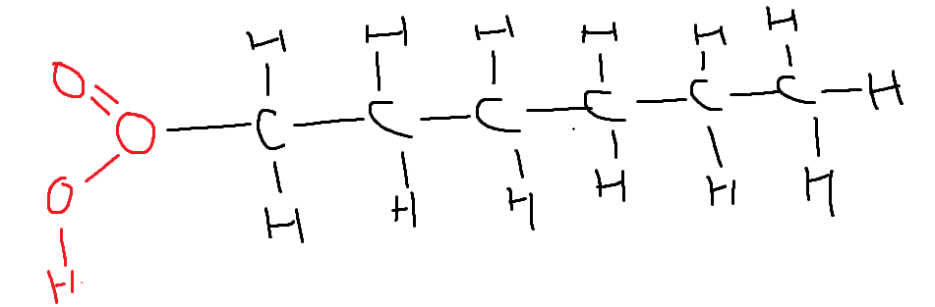

4. Draw an unsaturated fat.

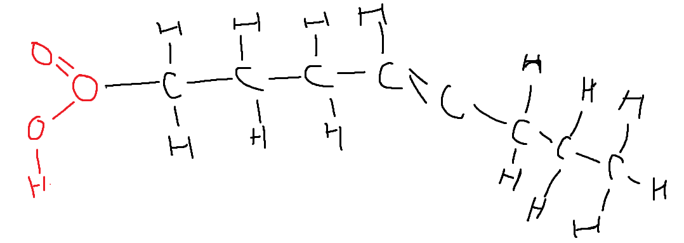

5. What does it mean for lipids to emulsify? Explain the process, starting with what you saw in connect.

They can cause triglycerides to mix with water, seen when the crushed potato mixed with the water.

6. According to Connect, what is a good test for fat?

The paper test.

**V. Reflection**

Each person should write up a reflection of 2 interesting concepts that they learned in lab today and at least one question that they have. Then use Google to attempt to research the answer to your question.

I found it pretty interesting how even though sugars are not in some of the things that we may eat, the way that our body adjusts to things like starches is to break it down into sugars anyways as it is easier for us to handle and manage. Another thing is how simply adding some new agent to a solution, we can tell what was in the initial solution by how it reacts with the new agent. Something that would be cool to see is how our body regulates the glucose levels in our blood and what makes it different for some people compared to others.